


ANSYS LAB X – Title
Sec 2
Team 4
  - Machine Construction
  - Members
Name | ID
Omnia Raafat Sweed | 2200484
Basant Aref Mahmoud | 2200379
Mohammad Amr Attia El Zaafarany | 2200587
Mohamed Ayman Rashad | 2200803
Toqa Mohamed Gaber | 2200476
Nouran Abdelmounem Mohamed | 2200273
Sama Mohamed Abd El-Halim | 2200336
Yehia Farid Salama | 2201324
Mohammed Hany Mohammed | 2201377

Submitted to Eng. Islam Maged

Table of Contents
Objective 3
Solutions 3
Problem x 3
Step x: Lorem ipsum dolor… 3

J
Lorem ipsum dolor…

Objective

Solutions

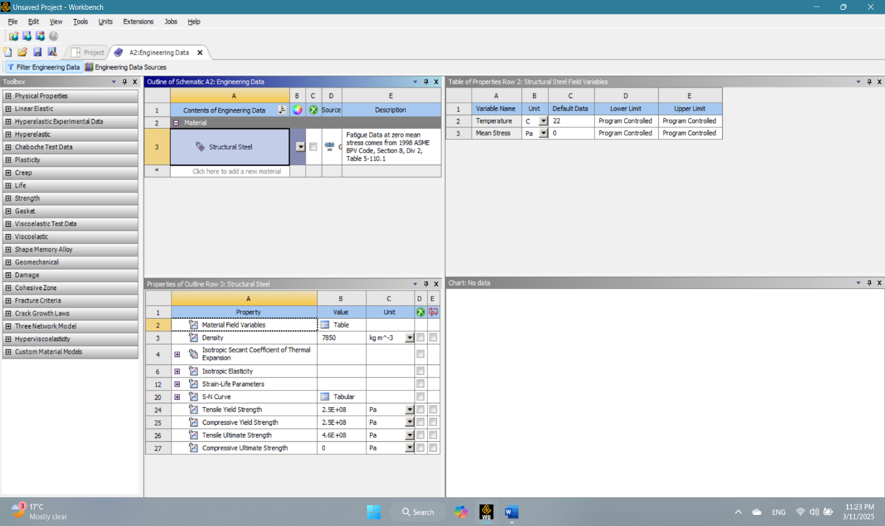
Problem x
J
Description
Lorem ipsum dolor…

Step x: Lorem ipsum dolor…

